katalon:

- Katalon is a complete web and mobile test automation tool (extends the capabilities of Selenium and Appium)
- Tool is available for windows and MAC
- It has a good GUI, where you can start creating and manage your test case
- It is free tool (http://www.katalon.com
- Ensure software quality (end-to-end testing and regression testing)
- Includes Page object model design for better management of web element
- Low –code test creation (Record and playback)
- Advanced test creation (Script mode : Java and groovy to generate more customized actions)
- Cross platform execution
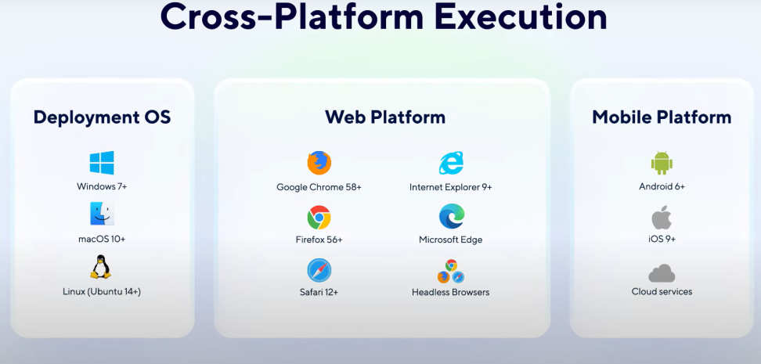
- Insightful test reporting (Log Viewer)
  - To export them in different formats like PDF and HTML
  - To keep track of your pass and fail patterns and execution trends over time studio’s built-in reporting toolwith test ops can take care of that

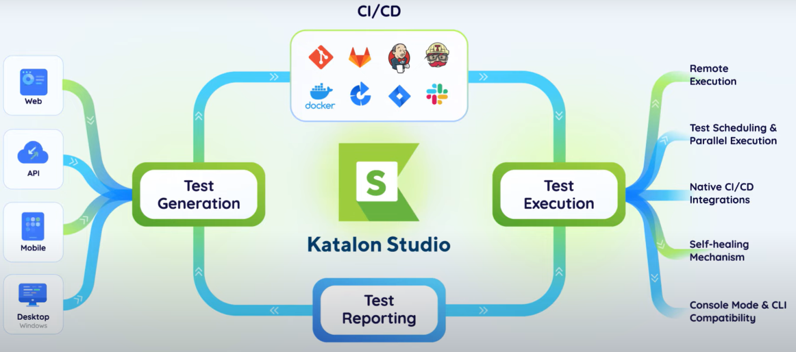

Installation:

- Register in katalon before you downlaod,remember email id and pwd.
- In google type katalon studio download for windows
- Click the link
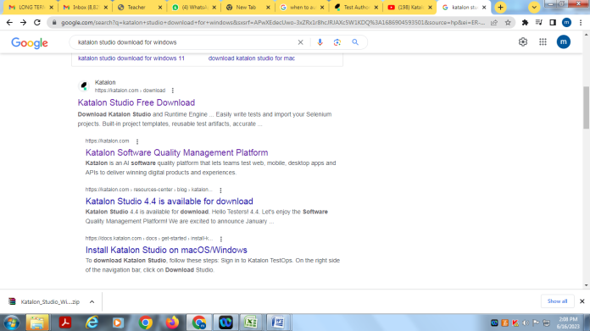
- select katalon studio enterprise, click on download button
- katalon studio zip file will be downloaded
- Unzip the file and double click on " katalon.exe" file
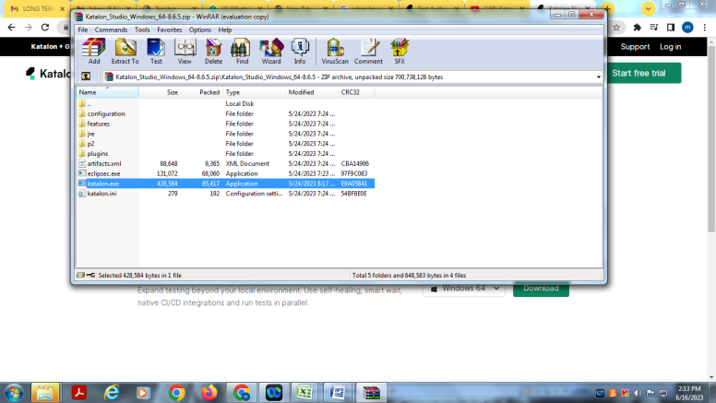
- After succesful installation, the studio will open and it will ask email id and password, need to give same email id and password that u given during registration.
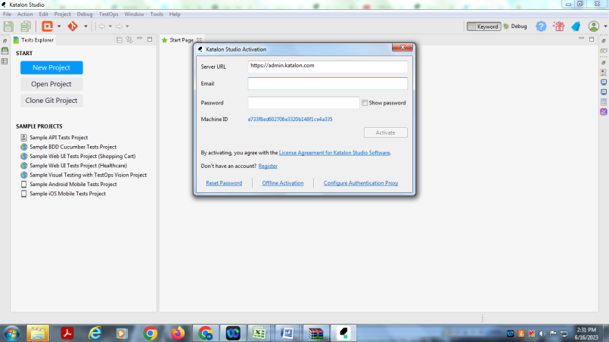

- it will take few seconds to open ur home of katalon , in between yoy will get getting started window , click may be later
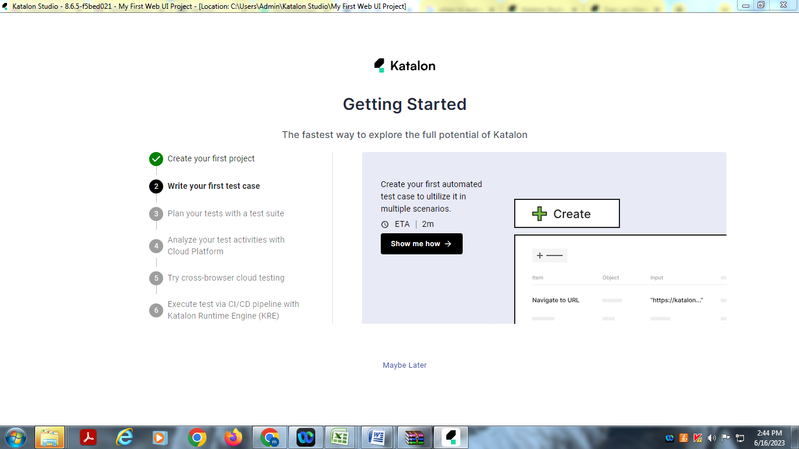
- Again you will get another window just click on k button
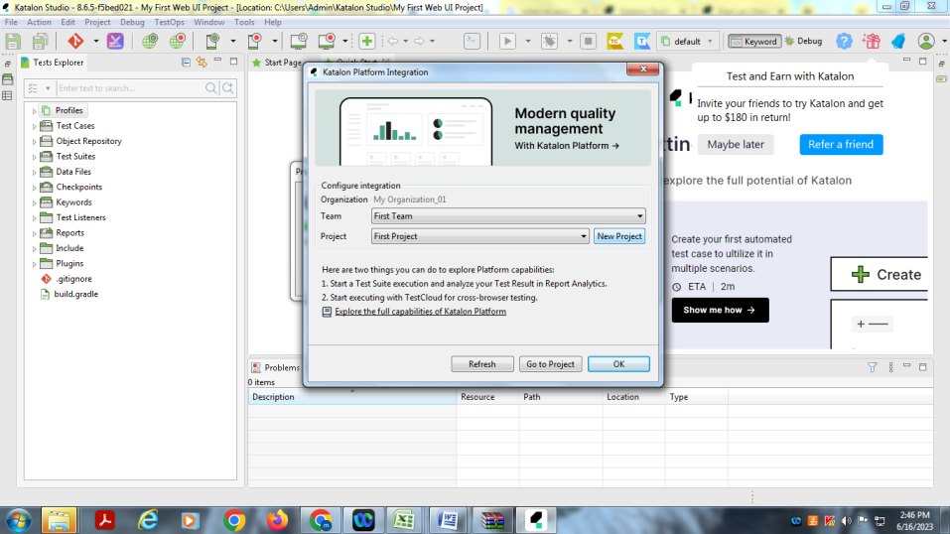
- you will be on ur home page
